Project Design Phase-II

Data Flow Diagram & User Stories

|  |  |
| --- | --- |
| Date | 15 October 2022 |
| Team ID | PNT2022TMID08708 |
| Project Name | Gas Leakage Monitoring and Alerting  System for Industries |
| Maximum Marks | 4 Marks |

**DATA FLOW DIAGRAM:**

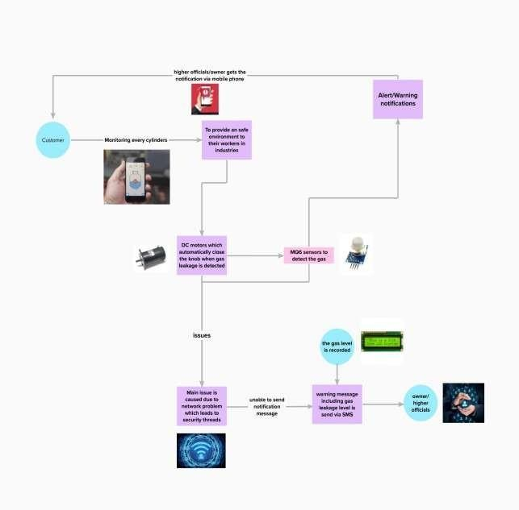

**User Stories**

Use the below template to list all the user stories for the product.

|  |  |  |  |  |  |  |
| --- | --- | --- | --- | --- | --- | --- |
| **User Type** | **Functional Requirement**  **(Epic)** | **User Story**  **Number** | **User Story / Task** | **Acceptance criteria** | **Priority** | **Release** |
| Customer(family | Registration | USN-1 | As a user ,I can | I can access my account / | High | Sprint-1 |
| member/industry | register for the | dashboard |
| owner) | device in the owners |  |
|  | mobile application by |  |
|  | entering my email |  |
|  | and password |  |
| Customer(higher | confirmation | USN-2 | As a user I will | I can receive confirmation | High | Sprint-1 |
| authority) | receive confirmation | email & click confirm |
|  | message via email |  |
|  | and once I received |  |
|  | I can install the |  |
|  | device in the |  |
|  | owners place |  |
| Customer  (fire service 101) | Safety measure register | USN-3 | As a register I can register the  application in | I can register & access the dashboard with Facebook Login | Low | Sprint-2 |
| owner/family |
| members mobile |
| phone |
| Customer (mobile user) | Mobile application | USN-4 | As a user I can register by mobile application | I can register for gas detection device with owners mobile number and the alert message  will be send by SMS | Medium | Sprint-1 |
| Customer | Login | USN-5 | As a user I can log | Mail address and passwords | High | Sprint-1 |
| (credential) | into the device by | are default |
|  | entering email & |  |
|  | password in the |  |
|  | owner’s mobile |  |
|  | application |  |
| Customer | Notification | USN-7 | As a user when | Alert message is sent to | High | Sprint-1 |
| (Web user) | there is a critical situation regarding  gas explosion the alert notification will | owners mobile as an SMS |
|  | be received through |  |
|  | GSM module |  |
| Customer care Executive | Network Connectivity | USN-8 | When there is a gas leakage is detected in the surrounding | Sensor detect the leakage and notifies the owner via message | High | Sprint-1 |
| **User Type** | **Functional**  **Requirement (Epic)** | **User**  **Story Number** | **User Story / Task** | **Acceptance criteria** | **Priority** | **Release** |
| Administration | Accessing | USN-9 | When there is an  issue in accessing the device | Admin/Device operator’s advice should be undertaken | High | Sprint-1 |